**UNIVERSITE ASSANE SECK DE ZIGUINCHOR**

**Licence 2 MPI**

**♦◊♦♦◊♦**

Année 2016-2017



**♦◊♦♦◊♦♦◊♦◊♦**

UFR Sciences et Techniques

**♦◊♦♦◊♦**

**Département d’informatique**

**Examen d’Architecture des Ordinateurs :** Session Normale

**Durée :** 3h00mn

Documents non autorisés

**Circuits combinatoires** *(8points)*

**Exercice 1:**

Soient les codes A et B représentés par les tableaux ci-dessous.

|  |  |  |
| --- | --- | --- |
| Code A | | |
| A2 | A1 | A0 |
| 0 | 0 | 0 |
| 0 | 0 | 1 |
| 0 | 1 | 0 |
| 0 | 1 | 1 |
| 1 | 0 | 0 |
| 1 | 0 | 1 |
| 1 | 1 | 0 |
| 1 | 1 | 1 |

|  |  |  |
| --- | --- | --- |
| Code B | | |
| B2 | B1 | B0 |
| 1 | 0 | 1 |
| 0 | 1 | 1 |
| 1 | 0 | 1 |
| 0 | 1 | 1 |
| 1 | 0 | 0 |
| 0 | 1 | 0 |
| 1 | 0 | 0 |
| 0 | 1 | 0 |

1. Quel circuit permet de transformer le code A en code B? *(1point)*
2. Donner les équations booléennes simplifiées de ce circuit transformateur du code A en code B. *(3points)*

**Exercice 2:**

Donner la table de vérité du circuit suivant. *(3points)*

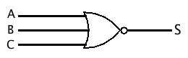

**Circuits séquentiels** *(12points)*

**Exercice 3: Circuit séquentiels** *(12points)*

Pour chacun des circuits séquentiels suivants, remplir la table de vérité (Clk=H).

|  |  |  |  |
| --- | --- | --- | --- |
| H | J | K | Q(t) |
| 0 | 0 | 0 |  |
| 0 | 0 | 1 |  |
| 0 | 1 | 0 |  |
| 0 | 1 | 1 |  |
| 1 | 0 | 0 |  |
| 1 | 0 | 1 |  |
| 1 | 1 | 0 |  |
| 1 | 1 | 1 |  |
| **Figure2** | | | |

|  |  |  |  |
| --- | --- | --- | --- |
| H | J | K | Q(t) |
| 0 | 0 | 0 |  |
| 0 | 0 | 1 |  |
| 0 | 1 | 0 |  |
| 0 | 1 | 1 |  |
| 1 | 0 | 0 |  |
| 1 | 0 | 1 |  |
| 1 | 1 | 0 |  |
| 1 | 1 | 1 |  |
| **Figure1** | | | |

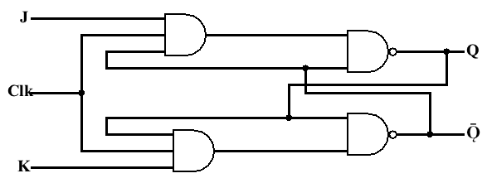 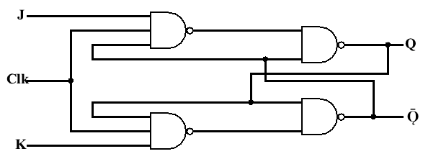

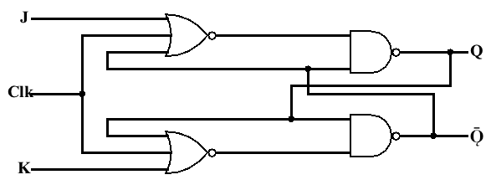 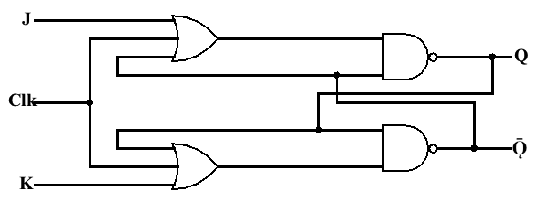

|  |  |  |  |
| --- | --- | --- | --- |
| H | J | K | Q(t) |
| 0 | 0 | 0 |  |
| 0 | 0 | 1 |  |
| 0 | 1 | 0 |  |
| 0 | 1 | 1 |  |
| 1 | 0 | 0 |  |
| 1 | 0 | 1 |  |
| 1 | 1 | 0 |  |
| 1 | 1 | 1 |  |
| **Figure4** | | | |

|  |  |  |  |
| --- | --- | --- | --- |
| H | J | K | Q(t) |
| 0 | 0 | 0 |  |
| 0 | 0 | 1 |  |
| 0 | 1 | 0 |  |
| 0 | 1 | 1 |  |
| 1 | 0 | 0 |  |
| 1 | 0 | 1 |  |
| 1 | 1 | 0 |  |
| 1 | 1 | 1 |  |
| **Figure3** | | | |

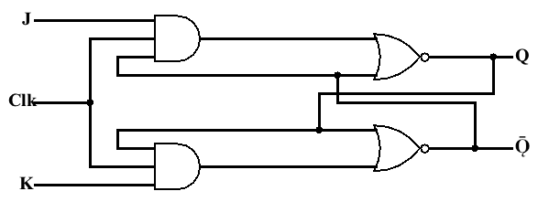 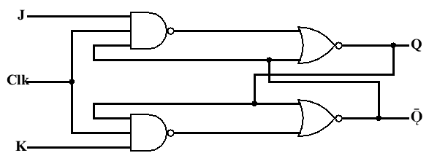

|  |  |  |  |
| --- | --- | --- | --- |
| H | J | K | Q(t) |
| 0 | 0 | 0 |  |
| 0 | 0 | 1 |  |
| 0 | 1 | 0 |  |
| 0 | 1 | 1 |  |
| 1 | 0 | 0 |  |
| 1 | 0 | 1 |  |
| 1 | 1 | 0 |  |
| 1 | 1 | 1 |  |
| **Figure6** | | | |

|  |  |  |  |
| --- | --- | --- | --- |
| H | J | K | Q(t) |
| 0 | 0 | 0 |  |
| 0 | 0 | 1 |  |
| 0 | 1 | 0 |  |
| 0 | 1 | 1 |  |
| 1 | 0 | 0 |  |
| 1 | 0 | 1 |  |
| 1 | 1 | 0 |  |
| 1 | 1 | 1 |  |
| **Figure5** | | | |

|  |  |  |  |
| --- | --- | --- | --- |
| H | J | K | Q(t) |
| 0 | 0 | 0 |  |
| 0 | 0 | 1 |  |
| 0 | 1 | 0 |  |
| 0 | 1 | 1 |  |
| 1 | 0 | 0 |  |
| 1 | 0 | 1 |  |
| 1 | 1 | 0 |  |
| 1 | 1 | 1 |  |
| **Figure7** | | | |

|  |  |  |  |
| --- | --- | --- | --- |
| H | R | S | Q(t) |
| 0 | 0 | 0 |  |
| 0 | 0 | 1 |  |
| 0 | 1 | 0 |  |
| 0 | 1 | 1 |  |
| 1 | 0 | 0 |  |
| 1 | 0 | 1 |  |
| 1 | 1 | 0 |  |
| 1 | 1 | 1 |  |
| **Figure8** | | | |

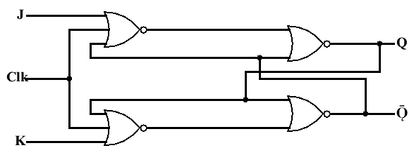 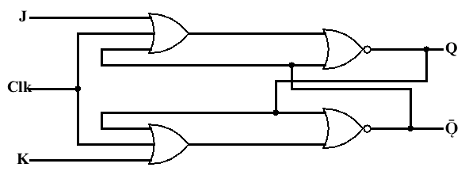

1. Lesquelles fonctionnent comme une bascule JK synchrone avec le niveau haut de Clk=H?

……………………………………………………………………………………………..

1. Lesquelles fonctionnent comme une bascule JK synchrone avec le niveau bas de l’horloge Clk?

…………………………………**………………………………………………………………….**

1. Compléter le chronogramme suivant pour la **Figure7**.

